EduTutor AI: Personalized Learning with Generative AI and LMS Integration

Leader: SIVANESAN.M

Team Member: SIVARANJAN.S

Team Member: SRIRAM.P

Team Member: SRIHARISH.K

# 1. Introduction

EduTutor AI is an AI-powered personalized education platform that revolutionizes the way students  
learn and educators assess progress. It provides dynamic quiz generation, student evaluation,  
Google Classroom integration, and real-time feedback—all powered by IBM Watsonx and Granite  
foundation models.

# 2. Project Overview

Purpose: The purpose of EduTutor AI is to create a personalized and adaptive learning  
environment that helps students improve their skills through tailored quizzes, smart feedback, and  
progress tracking. It empowers educators with AI-driven insights to evaluate performance and  
recommend learning paths.  
  
Features:  
- Dynamic Quiz Generation  
- Student Performance Evaluation  
- Google Classroom Integration  
- AI-Powered Feedback  
- Real-time Progress Tracking  
- Multi-modal Input Support  
- User-Friendly Dashboard Interface

# 3. Architecture

Frontend: Built with React/Streamlit for an interactive and user-friendly UI.  
Backend: Implemented with FastAPI to handle quiz generation, evaluation, and feedback APIs.  
LLM Integration: IBM Watsonx Granite models for text generation, evaluation, and  
recommendations.  
Database: MySQL for storing user details, results, and learning data.  
Integration: Google Classroom API for seamless learning management system connectivity.

# 4. Setup Instructions

Prerequisites:  
- Python 3.9 or later  
- FastAPI and required libraries  
- IBM Watsonx API key  
- MySQL server setup  
  
Installation Steps:  
1. Clone the repository  
2. Install dependencies from requirements.txt  
3. Configure database in .env file  
4. Run FastAPI backend server  
5. Launch frontend dashboard  
6. Start interacting with EduTutor AI modules

# 5. Folder Structure

app/ – Backend APIs and business logic  
ui/ – Frontend code and dashboards  
models/ – Machine learning and LLM integration  
database/ – MySQL configurations  
docs/ – Documentation and reports  
main.py – Entry point to run the backend server

# 6. Running the Application

➢ Start FastAPI server  
➢ Launch React/Streamlit dashboard  
➢ Navigate through the quiz, performance, and feedback pages  
➢ Upload student data, generate quizzes, and review AI feedback

# 7. API Documentation

Available APIs:  
- POST /quiz/generate – Generates quizzes dynamically  
- POST /evaluate – Evaluates student answers  
- GET /progress – Retrieves student progress reports  
- POST /feedback – Provides AI-generated learning feedback  
- GET /classroom/sync – Integrates with Google Classroom

# 8. Authentication

EduTutor AI supports:  
- JWT-based authentication  
- Role-based access control (Admin, Educator, Student)  
- Secure API key for third-party integrations

# 9. User Interface

The UI is minimal and interactive, providing:  
- Sidebar navigation for modules  
- Quiz interface  
- Student progress charts  
- AI-generated feedback panel  
- Report download option

# 10. Testing

Testing Phases:  
- Unit Testing (Quiz generation, evaluation logic)  
- API Testing (via Swagger, Postman)  
- Manual Testing (student flows, quiz attempts)  
- Edge Cases (incorrect inputs, invalid logins)  
- Integration Testing (Google Classroom sync)

# 12. Known Issues

- Limited offline support  
- Dependency on Watsonx cloud availability  
- Basic UI theme (can be enhanced)

# 13. Future Enhancements

- Add voice-based quiz interaction  
- Mobile app version  
- Multi-language support  
- Advanced analytics dashboards  
- Offline learning mode

# 14. Screenshots & Outputs

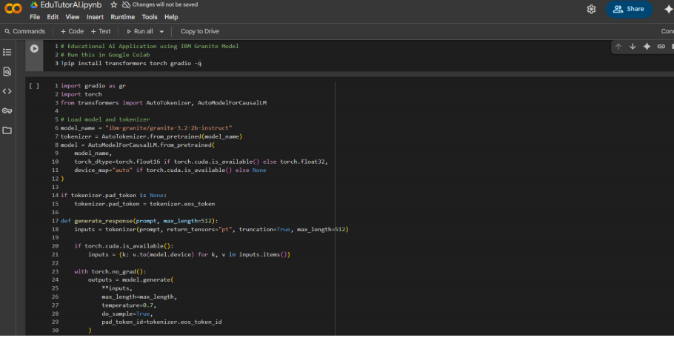

Figure 1: Google Colab - Model Import and Setup

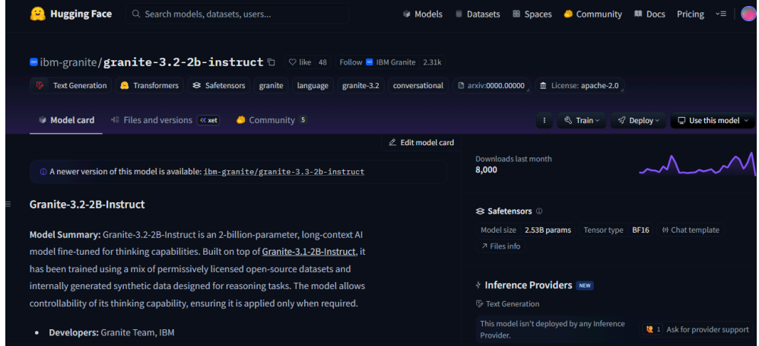

Figure 2: Hugging Face - IBM Granite Model Page

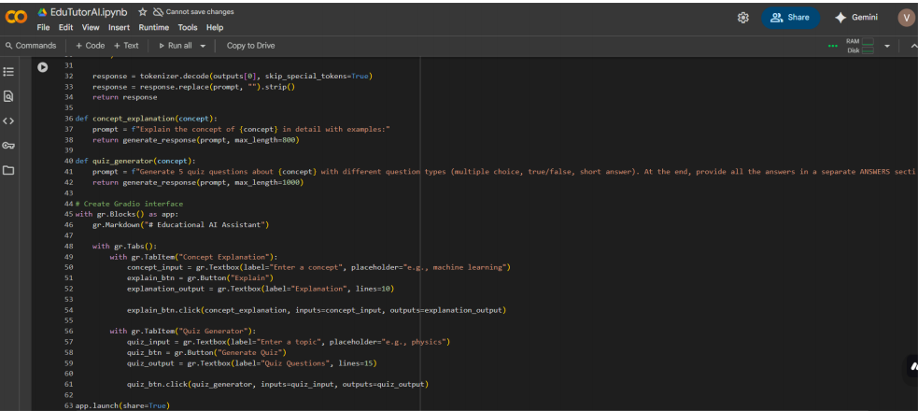

Figure 3: Google Colab - Application Code with Gradio UI